**Middleware of Technical Diagram:**

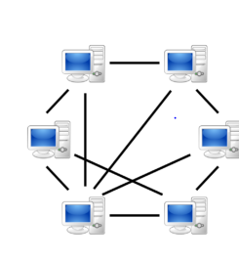



P2P Network

**Overview of Technical Diagram:**



**Technical Architectural Diagram:**



Our system contains a mobile app and a web app, and their total processing is made more efficient by a load balancer, which divides incoming network traffic across a cluster of three dispersed servers.

**Load Balancing:**

**System architectural Diagram:**

